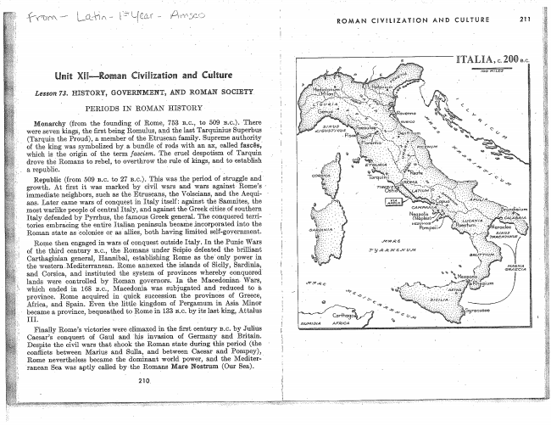

mit Elu-@a an Miur@

Lesson 73. HESTORY, GOVERNMENT, D ROMAN SOCIETY

PERIODS IN ROMAN HISTORY

Monarchy (from the _founding of Rome, 753 3.o., to 509 13.12.). There were Seven kings, the first being Romulus, aud the last Tarquíníus Superbus (Tarquin the Proud), a member of the Etruseeu family. Supreme authority of the king was symbolized by a bundle of rods with an ax, called fasses,l which is `the origin of the term fascism. The cruel despotism of Tarquin drove the Romans to rebel, to overthrow the rule of kings, and to establish

s republic. -

immediate neighbors, such as the Etruseans, the Volseíans, and the Aequians. Later came Wars of conquest in Italy itself: against the Samnites, the moet Warlike people of central Italy, and against the Greek cities _of southern Italy defended by Pyrrhus, the famous Greek general. The conquered territories embracing the entire italian peninsula, became .incorporated into the Roman state as 'colonies or as allies, both having limited self-government.

_Rome then engaged'in-Wars of conquest outside Italy. In the Plinio Wars of the third century 13.0., the Romans under Scípio defeated the brilliant Carthagìnian general, Hannibal, establishing Rome as the'only power in the WesternlVlediterranean. Rome annexed the islands of Sicily, Sardinia,and Corsica, and instituted the system of provinces whereby conquered.V ìands Were controlled by Roman governors. In 'the Wars, which ended in 168 13.0., Macedonia. was subjugeted ‘to a province. Rome acquired in quick succession the provinces of Greece, Africa, and Spain.' Even the little-kingdom of Éergamum in Asia, Minor ' became a province, bequeathed to _Romein 133 BLG. by its last king, Attalus

III.

Finally Rome’s victories Were elimexed in the ñrst century 13.0. by Julius Caeser’s conquest of Gaul and Vhis. invasion of Germany and Britain. Despite the civil Wars that shook ‘the Roman state during this period (the eonñiets between Marius and Sulla, and between Caesar and Pompey),

Rome nevertheless became the dominent world power, and the Mediter-­

rameau Sea. Was aptly called bythe Romans Mare Nostrum (Our Sea).

210.

ROMAN CIVELIZATEON

AND CULTURE 211

AFRICA

GEA ECIA

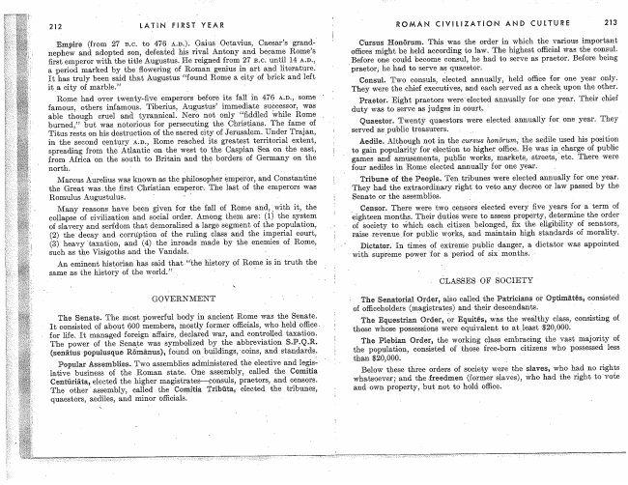

212 LATíN FIRST YEAR

nephew and adopted son, defeated his rival Antony and became R0me’s first emperor with the Augustus. He reigned from 27 :3.0. until 14 en., a. period marked by the flowering; of RomanV genius in art and literature. It has truly been said that Augustus “found Rome e, city of brick and left ite eíty of marble.” A

Rome had over twenty-five emperors before its fall in 476 A.D., some famous, otheŕs infamous. Tiberius, Augustus’ immediate suocessor, was able though cruel and tyrannical. Nero not only “ñddled While Rome burned,” but Was notorious for persooutíng the Christians. The fame of Titus rests on his destruction of the sacred city of Jerusalem. Under Trajan, in the second oentury Am., Rome reached its greatest territorial extent, spreading from the'Atlantio on the West to the Caspian Sea on the east, from Africal on the south to Britain and the borders of Germany on the

north. '

Marcus Àureiius was known as the philosopher èmper'or, and Consńantiné the Great' Was,the first Christian emperor. The last of the empeïors Was Romulus Augustulus. A

Many reasons have been given for the fall of Rome and, _with it, the collapse 0f- cívílízatíon and social order. Among; them are: (l) the system of slavery and serfdom that demoralízed a large segment of the popnlation, (2) the ¿lecay and corruption of the ruling class `and the imperial court, (3) heavy taxation, and (4) the ímoads made by the enemies of Rome, such as the Vísigoths and the Vandaìs. - _

An eminent hístprían has said that history of Rome in tfuth the same as the history of the World." l

GOVERNMENT

The Senate. The most powerful body in ancient Home was the Senate.

it consisted of about 600 members, mostly former Who held office.

for life. It managed foreign affairs, declared War, and controïlod taxation. The power of the Senate Was symbolized by ‘the abbreviation S.P.Q.R. (senätus populusque Römânus), found and standards.

Populair Assemblies. TWG assemblies administered the elective and legislatíve business of the Roman state. One assembly, called the Comitia Centûriäia, elected the higher magistrstewçonsuls, praetors, and censors. The otherŕassembly, called the Comîtia elected the tribunes, quaestors, eedíles, and minor

ROMAN CIVILIZATION AND CULTURE 213

Cursus Honörum. This Was the order in which the Various important offices might be held according to MW. The highest ofñ'cial Was the consul. Before one could become consul, he had to Serve as praetor. Before being

'praetoq he had to 'serve afs quaestor.

Consul. TWO consuls, elected annually, held one year only. They were the chief executives, and each served as a cheek upon the other`

Praetqr. Eight praetors Were'eìected annually for one year. Their chief duty Was to serve as judges in court.

Quaestor. Twenty 'quaestors were elected annuallyv for one year. They served as'public treasurers. _ _l

Aedile. Although not in the cursus the aedile used his position to gain popularity for election to higher He was in charge of public games and' amusements, public Works, markets, streetsfete. There Were four @ediles in Rome elected annually for one year.

Tribune of the People. Ten tribunes Were elected annualiy for ene year. They had the extraordinary right' to veto any decree or law passed by the Senate or the assemblies. '

,_ Censor. There were two censors elected every five years for a term' of eighteen months. Their duties were to assess property, determine the order of Society to which eaeh citizen belonged, the eligibility of senators, raise revenueior publie Works, and maintain high standards` of morality.

Dictator. In times 0f extreme publie danger, a, dictator Was appointed with supreme powerful' e. period of six' months.

CLASSES OF SOCIETY

The Senatorial Order, also called the Patrìcîans or Optimâtës, consisted of oñ'iceholders (magistrates) and their descendants. '

The Equestrian Order,_or Equítëls, Wàs the Wealthy class, consisting of those Whose possessions Were equivalent to at.least­51ß20,000.

The Plebian Order, the Working class embracing the vast majority of the population, consisted of those free-bom Citizens Who possessed less than $20,000.

Below thèse three orders of society were the slaves, who had no rights whatsoever; and the .freedmen (former slaves), who had the right, to'vote and own property, but not to hold

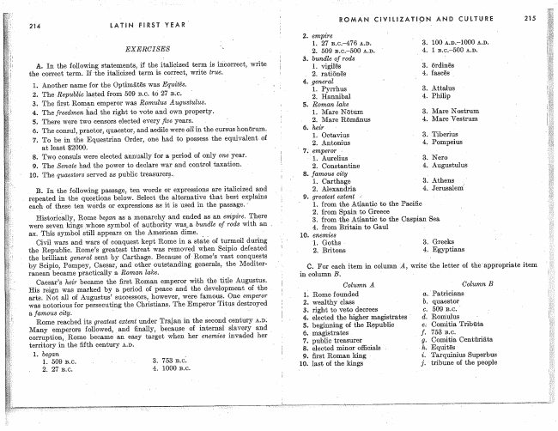

214 LATIN FIRST YEAR'

EXERCISES ï

A. In the following statements, if the term ís 'îńèorrect, Write the correct term.. Ifthe italicized term is correct, Write true.

l. Another- name for the Optimâtês was

The Republic lasted from 509 13.0. tó 27 15.0,.

The ñrst Romîm emperor was Romulus Augustulus.

The freedmen had the right to vote and own property.

There were two censprs elected every _jive years. Y i

r The consul, praetor, quaestor, and sedile were all in the cursus honörum. To be in the Equestrian Order, one had, to possess the equivalent of at least $2000. Y _

8. Two consuls were elected annually for a period of only ondyear.

9. The Senate had the power to declare War and control taxation.

10. The quaestors served as public treasurer§..

B. In the following passage, ten Words or expressions are italicized and . repeated in the questions below. Select the alternative that best explains

eaell of these ten Words or expressions as it is used in the passage.

Historíeelly, Rome began as a, monarchy and ended as an empire. There were seven kings `Whose symbol of authority WasJa, bundle of rods with a. ax. This symbol still appears on the American dime. Y _

Civil Wars and Wars of conquest kept Rome in a state of turmoil during the Republic. Rome@ greatest threat was removed When defeated the brilliant geńeml sent by Carthage. Because of‘Rome’s Vast conquests by Scipio, Pompey, Caesar, and other outstanding generale, the Mediterranean became practically a Roman lake.

Caesars heir became the ñrst Roman emperor with the title Augustus. His reign Wes marked by a. period of peace and the development of the arts. Not all of Augustus’ successors, however, famous. One emperor Wes notorious for perseoutíng the Christians.. The Emperor Titus destroyed a famous city. Y

Rome reached its greatest extent under Trajan in the Second. c_entury AJ);

Many emperors folfowed, _and finally, because intemgl slavery and

corruuptíonîRome becamé easy target When her enemies invaded hea1 territory in the ‘fifth century AAD.

10.

ROMAN CIVILIZATIQN AND CULTURE

3. bundle of rods

1.

2. ratìönês .

l. Pyrrhus 2. Hannibal

. Roman lake

l. Mare Nötum 2. Mare Römänus

. heir

1. Octavíus 2. Antonius

_emperor

l. Aurelius 2. Constantine . famous city

1. Carthage

2. Alexandria

, greatest extent

Attalus

4. Philip

2. from Spain to Greece

Mare Nostrum Mare Vestrum

Tiberius Pompeius

Nero Augustulus

. Athens I . Jerusalem'

from -the Atlantic to the Caspian 'Sea

4. from Britain to Gaul enemies

‘1. Goths -

2. Britons

C. For ítem in column A, Write' the letter of theappropïíate item

in column B.

Column A

. Rome founded . Wealthy class . right to Veto decrees

. beginning of the Republic

magistrates

public treasurer

elected minor .

. ñrst Roman king

last of the kings

. elected the higher magistïates '

3. 4.

Greeks

Egyptians

Column B

215

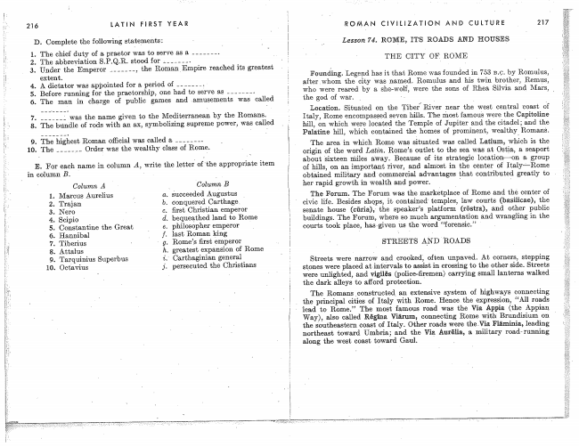

216 LATIN FIRST YEAR

D. Complete the following statements:

7'. was thename given to the Mediterranean by the Romans. 8. The bundle of rods with an ax, symbolízíng supreme power, was called

9. The highest Roman oñîcial Was called a 10. The Order was the Wealthy class of Rome.

E. For each _name in column A, Write the letterV of ‘the appropriate item in column B.

Column B

Column A ì. Marcus Aurelius ‘_ a. áucceeded Augustus _ 2. Trajan b. conquered Carthage. 3. . c. ñrst Christian emperor

4. Seipio - ci. bequeathed land to Rome 5. Constantine the Great e. philosopher emperor

6. Hannibal 'l f. last Roman king 7. Tiberius - ' g. Romefs ñrst emperor

8. Attalus h. greatest expansion of Rome 9. T arquìnius Superbus i.' Caïthagínían general

10. Octavius j. persecuted the

.ROMAN CIVILIZATHON AND CULTURE 217

Lesson 74. ROME, ITS ROADS AND HOUSES

THE CITY OF.l ROME

Founding. Legend has it that Rome was founded ín '753 by Romulus, afterwhom ‘the city was named. Romulus and his twin brother, Remus, who were reared by a she-Wolf, were the sons of Rhea, Silvia and Mars, _ the god of War. _

Location. Situated on the Tiber/ River near the west central `coast of italy, Rome encompassed seven hills. The most famous Were the Capitoline hill, on which Were located the Temple of Jupiter and the Citadel;l and the Palatine hill, which contained the homes of prominent, Wealthy` Romans.

The area in which Rome was situated was called Latium, which is the origin of the Word Latín. R0me’s outlet to the sea was at Ostia, a seaport about 'sixteen miles away. Because of its strategic a group of hills, on an important river, and almost in the center of obtained military and commercial advantages @hat contributed greatly to Y hor rapid growth in Wealth and power. '

The Forum. The Forum was the marketplace of Rome and the center of civic life. Besides shops, it contained' temples, law courts (basiiicae), the senate house (Giuria),` the speaker’s platform (röstra), and other public buildings. The Femm, where eo argumentation and wrangling in the courts took place, hasgiven us the 'Word “forensic”

STREETS A_ND ROADS

Streets Were narrow and crooked', often unpaved. At corners, stepping stones were placed at. intervals to assist. in crossing to the other side. Streets Were unlíghted, and vigilës (police-firemen) carrying small lanterns Walked the dark alleys to afford protection.

The Romans _constructed an extensive system of highways connecting

Y the principal cities of Italy With Rome. Hence the expression, “All roads 'lead to Rome.” The mest famous road was the Via Appia (the Appian _

Way), also called Régina Viârum, connecting Rome with' Brundísíum 011 the Southeastern coast of Italy. Other roads were thaVia. Fläminia, leading; northeast toward Umbria; and the Vial Amélia, a. military road» running along the West coast toward Gaul.

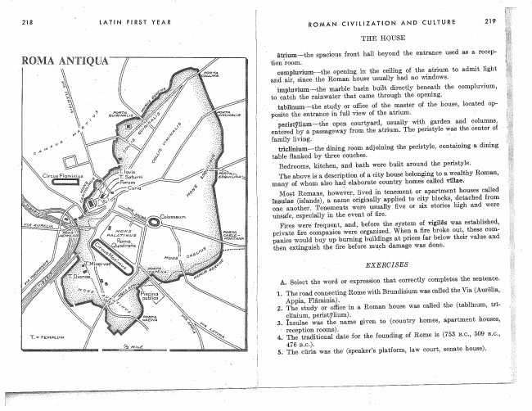

218

T. TEMPLUM

LATIN FIRST

YEAR

Colosseum

ROMAN ClvlllzATloN AND CULTURE -219

THE HOUSE

ätgium~the spacious front hall beyond the entrance used as a recep­ tion room.

compluvium-the opening in the ceiling of the atrium to admit light and air, since the Roman house usually had no Windows.

­impluvìum--the. marble basin built directly beneath the eompluvium, to eateh the rainwater that came through the opening.

tablînumwthe study or ,of the master of the house, ìocated opposite the entrance in View of the atrium. Y

AIperi.s.tiflllllrn--tHe open courtyard, usually with garden and columns, entered by a, passageway from the atrium. The peristyle was the center of ' family living. . ' ' l

triclînium-«the'dining room adjoining the perístyìe, containing a. dining table Hanked by three couches.

Bedrooms, kitchen, and bath were buil@ around the perístyle.

The is a. description of a cità)r house belonging to a Wealthy Roman, many-of Whom also ha@ elaborato country homes called vìllac.

Most Romains, however, lived in tenement or apartment houses called insuiae (islande), a name originaîìyfapplíed to city blocks, detached from one another. Tenements Were usuaìly five or six stories high and were unsafe, especially in the event of ñre. I

Fires Were frequent, and, before the system of vigilës was established, private fire companies Were organized. When a lire broke out, these com~ panies would buy up- burning buildings at prices far below value and then extinguish the fire bef-ore mueh damage was done.

EXERCISES

A. Select Jche Word or expression that correctly completes the sentence.

reception rooms). 4. The traditional date .for of Rome is (753 13.0., 509 13.0.,

476 13.6.). 5. The was the' (s'pe&ker’s platform, law court, senate house).

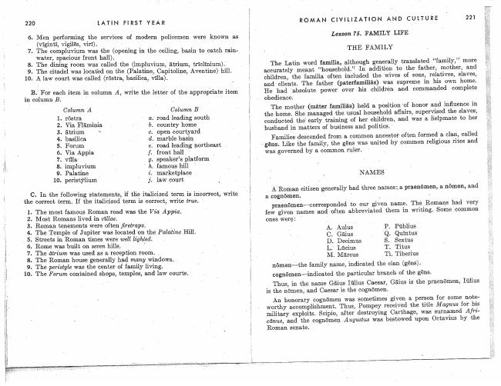

220 LATIN FIRST YEAR

6. Men performing the services of modern policemen were known as

vigilës, 7. The compluvium was the (opening in the ceiling, basin-_to catch rain

Water, spacious front hall). _ 8. The dining room Was called the (ímpluvíum, ätrium, tric1îníum).' 9. The Citadel was looatêd on the (Palatine, Capítolíne, Aventine) hill. 10. A law court Was called (röstra, basílica, Vñla). A

B.' For each item in column A, Write the letter of the appropriate item in column B. _

Column B

C. In the following statements, if the itálicized term is incorrect, Write the correct term. If the italicized term is Correct, Write true.

. The most famous Roman road was thè Vía Appia.

. Most Romans lived in vîllae.

Roman tenements were often jùretmps.

The Temple of Jupiter was loèated ¿n the Palatine Hin. Streets in Roman times were wel! lighted.

Rome Was built on seven hills,

The was used as a reception room. _

The Roman house generally had mamy Windows.

The perístyle was the center of famíìy living.

The Formé; contained. shops, temples, and law courts. ._

ROMAN CiVIUZATION AND CULTURE 221

Lesson YS. FAMILY LIFE

THE FAMÍLY

The Latin Word familia., although generally translated "famüy," more eccurately meant In addition to the father, mother, and. children, the familia often inclucheçìV the Wives of sons, relatives, slaves, ummm“, „__“ „www Y and clients. The father (paterfamìlìás) was supreme in 'his own home. He had Vfalbsulute power over his children and commanded complete

obedience; _ _

The mother V(rnärtel: held a position 'of honor and influence in the home. She managed the usual househoîd affairs, supervised the slaves, oonduotedlthe’ training of her children, and Was a Helpmste to her husband matters of'busíness and politics.

Families descended from a. common ancestor often formed a clam, called

Like ’the family, was united by common religious rites and

was governed by a common ruler.

'NAMES

AhRoman citizen generally had three@ unanimi-"§13J praenömen, a nômen, and

a cognömen. _ _

praenömen-corresponded to :jur given name. The Romans had few given'names and ‘often abbreviated them ín Writing. Some common

nömenm-the family name, indicated the Gian (gêns).

cognömen-Hindícated the particular brauch of the gêns.

Thus, in the name Cáesar, is the praenömen, is the uömen, and Caesar is the cognömen. _

honorary cognömen was sometimes given a person for some noteworthy adcomplíshment. Thus, Pompey received the title Magnus for his

Y i J A. f..."

Roman senate.

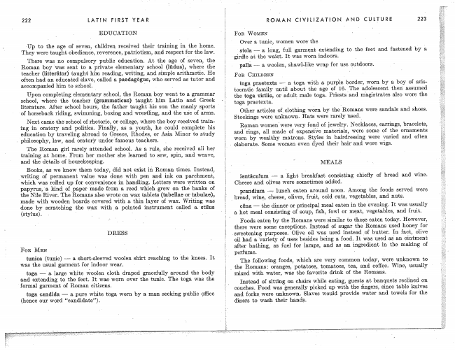

222 lATIN FIRST YEAR

EDUCATION

VUp to the age 0f seven, children received their training in the home. They Weïe taught obedience, reverence, patriotism, _and respect for the law.

There was ne compulsory public education. At the ege cf seven, the Roman bey was Vsent to a private elementary school (lùdus), Where the teacher (litterätor) taught him reading, writing, and simple arithmetic. He often had an educated slave, called a paedagögus, who served as tutor and accompanied him to school.

Upon completing elementary school, the Roman boy Went to a grammar school, “Where the teacher (grammaticus) taught him Latin and Greek literature. After school hours, the father taught his son the manly sports 'of horseback riding, swimming, boxing and Wrestling, and the use of arms.

Next came the' school of rhetoric, or college, Where the boy received train­ ing in oïatory and politics. Finally, as a. youth, he could. complete his education by traveliríg abroad to Greece, Rhodes, or Asia. Miliol` to study

A philosophy, law, and oratori7 under famous teachers.

The Roman girl rarely attended school. As a rule, She received her training at home. From her mother she îeamed to sew, spin, 'and Weave, and Jehe details of housekeeping.

Books, as We know them today, did not exist Roman times. Instead, Writing of permanent value Was done with pen and ink on parchment, which was rolled up for convenience in handling. Letters were Written on papyrus, 'a kind of_ paper made from a reed which grew on the banks of the Nile River. The Romans also Wrote on Wax tablets (tabellae or tabulae), made with Wooden boards covered with a thin layer of Wax. Writing was done by scratching the Wax with@ pointed instrument called a. stilus

(stylus}. A ' _ ' - -

FOR MEN

tunica (tunic) _ a shorbsleeved Woolen shirt reaching to `the knees. It was the usual gafment for indoor Wear. -

toga -m- a, large White vreoleu cloth draped gracefully around the body end extending to the feet. It was Worn over the tunic. The toga was the 'formal garment of Roman citizens.

toga candida -- a pure White toga Worn by a man seeking public @ffice (hence our word “candidate”).

ROMAN CIVIUZÀTION AND CULTURE 223

FOR WOMEN

Over a. tunic, women WoreV the

Stola. a, long, full garment extending to the feet and fastened by à, girdle at the Waist, It was wom indoors. _

pallà W a, Woolen, Shawl-like Wrap for use Qutdooŕs.

FOR CHILDREN

toga praetexta w a, toga. with a purple; border, Worn by a boy of tooïatíc family until about the age of 16. `The adolescent than' assumed the ‘toga virîlis, 01' adult male toga. Priests and magistrates also Wore the toga. praetexta.

Other articles of,c10thing wórn by- the Romans were sandals and shoes. Stockings Were; unknown. Hats were rarely used.'

Roman women'were very fone. »of jewelry. Necklaces, earrings, b_reeelets, and rings, all made of expensive materials, were some of the ornements Worn by Wealthy matrons. Styles in heírdressírlg were varied and often

MEALS

a light bŕeakfast consisting chiefly of bread and Wine. Cheese and olives were sometimes added.

prandìum -f lunch eaten around noon. Amo-ng _the foods served were

Y brëad, Wine, cheese, olives, fruit, cold Guts, Vegetables, and nuts.

cënal m the dìnnerlor principal meal eaten in It was usually a hot meal consisting of soup, fowl or mçat, vegetables, and fruit.

Foods eatenÍ by the Romans were similar to those eaten today. However, there were some exceptions. Instead of sugar the Romans used

-sweeteníng purposesfOLive oil was used instead lof butter. In fact, olive

oil had a of usesÍ besides being a food. It was used as. an ointment after bathing, as fuel for lamps, and as an ingredient in the making of perfume. ' A

The following foods, which are Very common tod-ay, were unknownŕto

_ the Romans: oí'anges, potatoes, tomatoes, tea, and coffoe.- Wine, usually

mixed with Water, was the favorite drink of the Romans.

Instead. of sitting on chairs While eating', guests at banquets reolined on couches. Food was generally picked up with the fingers, since table knives and forksV Were unknown. Slaves Would provide Water and towels for the

diners to Wash their hands.

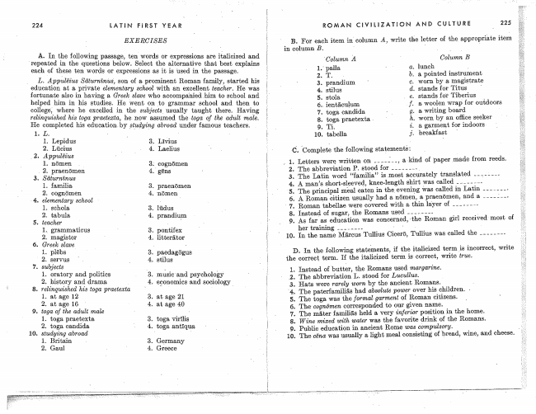

224 LATiN' FIRST YEAR

EXERCÍSES

A. In the following passage, ten Words or expressions are ifalieízed and 'repeated in the questions below. Select the alternative that best explains

each of these ten Words or expressions as it is used in the passage.

_ L. Appulëíus Säturnïnus', son of a prominent Roman family, Started his education at a private elementary _school with an excellent teacher. He was fortunate also in having a Greekl slave who aocompa'níedhim to school and helped him in his studies. He lWent 0n to grammar school and then to college',­ where he excelled in the usually taught there. Having felínquíshed his toga pmeteacm, he. 110W assumed thertoga of the adult male. He completed his educaticnby §tudyz'ng abroad under famous teachers.

2. Gaul Y ' 4. Greece

B. For each item in` column A, Write the letter of the appropriáte ítem in column B. _ _ Y

ROMAN CEVILìZATEO'N AND CULTURE 225

Column B

Column A a. lunch 2. T. b. a pointed instrument 3. prandíum ' c. Worn by a; magistrate 4. stílus d. stands for Titus '

5. Stola e. stands for Tiberius

6.. íentäculum ' . f. a Wonlen Wrap for ou'idoors 7. toga candida _ g. a. Writing board ' praetexta h. wom by au office seeker 9. Tí. i. a garment for indoors 10. tabella j. breakfast

C. ÍComplete the folle-wing statementè: _» 1. Letters were Written on a, `kind of 'papermade from reeds.

2. The abbreviation P. stood for „___ __. _

3. The Latín Word. “familia” ís Vmost accurately translated ___-; __.

4;. A. man’s short«sleeved, knee-length shirt was called _____ __.

V5. The principal maal eaten in thel evening was called in Latin ___ ____. 6. A Roman citizen usually had a nörnen, a praenömen, and a _____-_. ' 7. Roman tabella@ were covered with a. thin lalyer of 8. instead of sugar, the Romans used __ ___ __. Y 9. As far as education was concerned,­the Roman girl received most, of

her training - lO. In the name Mârcus Tullius Cicerö, Tullius was called the

D. In. the following statomonts, if the italicized term is incorrect, Write e correctl term. If the italicized term is correct, Write true.

Instead of'butter, the Romans used margarine.

The abbreviation L. stood for Lucullus.

Hats were Tarely wom by the ancient Romans. Y The paterfamíliäs had power over his children.

The Èoga was the formal garment of Roman citizens.

TheV cognömen corresponded. to our given name.

The mäter famílíäs held a, Very inferior position in the home. Wine mixed with water was the favorite drink of the Romans. Public education in ancient Rome was còmpulsory. i The cëna was usually s. light meel consisting of bread, Wine, and cheese.

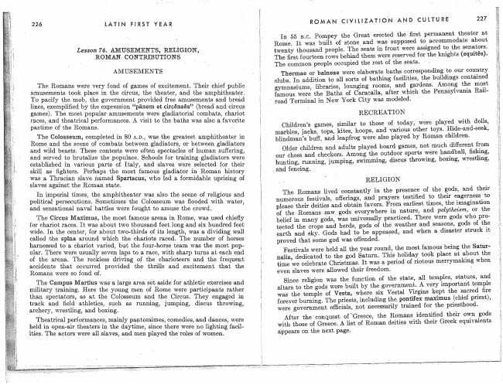

226 -LATIN FURST YEAR

Lesson 76. AMUSEMENTS, RELÍGION, ROMAN. CONTRIBUTIONS

AMUSEMENTS

The Colosseum, completed in 80 AAD., was the greatest amphítheater in Rome and the scene of combats between gladiatore, or between gladiators and Wild beasts. These contests l~were often spectacles of human suffering, and served to brutalìze the populace. Schools for training gladíators- Were established in various parte ei Italy, and sìaves Were selected for their skill as fighters. Perhaps-the moet famous gladíator in Roman history was a Thracían slave ńamed Spartacus; who led a formidable uprising of slaves against the Roman state.

In imperial times, the amphitheater was also the scene of religious and political perseoutíons. Sometimes the Colosseum was flooded with Water, and sensational naval battles were fought to .amuse the crowd.

The Circus Maximus, the most famous arena, in Rome', was used for'chariot races. It Was about two thousond feet long and six hundred feet wide. In'the center, for aboutJ two-thirds of its length, was a, dívídingwall coiled `fullo spina around which the chariots raced. The number of horses harnessed to a chariot varied, but the four-horse team Was the most popular. There Were usually seven laps to a race, with sharp turns at each end of the arena. The reckless driving of the charicteers and the frequent accidents that occurred provided the thrills and .excitement that the Romans were so fond of. '

The Campus Martins Wes'a, large aree set aside for athletic exercises and miìítary training. Here the young meri of Rome were participants rather than spectetors,. as et the Colosseum and the Circus. They engaged in track and fleld athletics, Such es running, jumping, discus throwing, archery, Wrestling, and boxing. .

Theatrical performances, mainly pantomimes, oomedies, and dances, were held in open-air theaters in daytime, ,since there Were no lighting facilities. The actors Were all slaves, and men played the roles of Women.

ROMAN CIVíLiZATüO-N AND CULTURE 227

In 55 13:0. Pompey the Great ereetedthe ñret permanent theater at Rome. It was built ofV stone and was supposed to accommodate about twenty thousand people. The seats ín front were assigned to the senators. The first fourteen rows behind them Were reserved foiln the knights

The common peopîe occupied the rest of the seats.

Thermae or balneae were elaborate baths corresponding to our country clubs. ln addition to all sorts of bathing facilities, the buildings contained gymnasiums, libraries, lounging rooms, and gardens. Among the most famous were the Baths of Caracalla, after which the Pennàylvanía Rail

` äermínal in New York City Wás modeled.

RECREATION

Cbildren’s games, similar to those 'of today, Were played Wit-h dolls, marbles, jaçks, tops, kites, hoops, and various other toys. Hide-and-seek, blíndman’e buff, and leapfrog; Were-also played by Roman children.

Older children and' adults played. board games, not much different from our chess and checkers. Among the outdoor spoïts were handball, ûshing, hunting, running, jumping, swimming, discus throwing, boxing, Wrestling, and fencing. l ' j

RELIGION

The Romans lived constantly in the presence of the gods, and their numerous festivals, offerings, and prayers testified to their eagerness to please their deities and obtain favors. From earliest times, the imagination oí the Romans saw gods everywhere in nature, and polythez'sm, or the belief in many gods, Was universally practiced. rI`here were gods who protected the crops and herds, gods of the Weather and seasons, gods of the earth and sky. Gods had to he appeased, and when adímster struck it proved that some god Was offended. l _

Festivals were held all the year round, the most famous being the Saturnalìa, dedicated to the god Saturn. This holiday took place at about the time We celebrate Christmas. It was a period' of ríotous merrymakíng when even slaves were allowed their freedom.

Since religion was the function of the state, all temples, Statues, and altais to the gods Were built by the government. A very importent temple was the temple of Vesta, where six Vestal Virgins kept the sacred fire forever burning. The priests, including the, Pontife-_X maximus (chief priest), were `government officiels, not necessarily trained. for the priesthood.

After the'ßonquest of \Greece, the Romans ídentíñed their own gods with those of Greece. A list of Roman deities with their Greek equivalents

appears on the next page.

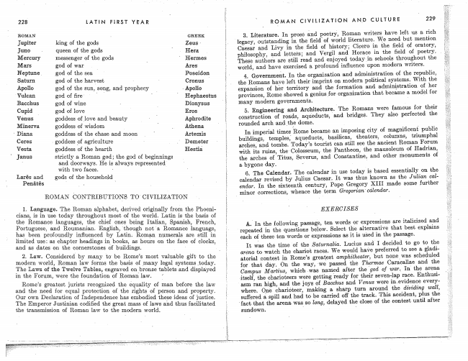

228 LATlN FERST YEAR

ROMAN Y GREEK

Jupiter king of the gods Zeus Y Juno A queen of the gods ' Hera. Mercury messenger of the gods ' Hermes Mars god of War . I Ares Neptune _god of the sea. _ Poseidon Saturn god of the' harvest Cronus _ Apolìo god ‘of the Sun, song, and prophecy »Apollo Vulcan god of ñre Y Hephaestus Bacchus god of Wine Y Dionysus Cupid god 0f love Eros

Venus l goddess of love and beauty _ L Aphrodite Minerva goddess of Wisdom u _ Athena.

Diana. goddess of the chase and moon Y Artemis

Ceres - goddess pf agriculture . .' Demeter Vesta goddess of the hearth Hestiá Janus Strictly a Roman god; the god of beginnings

and doorways. He is always represented' with two faces. '

and godsV of the household

Penätês

ROMAN CONTRIBUTIONS TOY OIVILIZATION

1. Language. The Roman alphabet, derived originally from the Phoenioians, is in use today throughout moet of the World. Latin-is the basis of the Romance languages, the chief ones being Italian, Spanish, French un" Portuguese, and Roumsnían. English, ‘though not 'a Romance language, has been profoundly influenced by Latín. Roman numerals are still in limited use: as chapter headings in books, as hours on the face of clocks, and as dates on the cornerstones of buildings. _ .

2. Law. Considered by many be Rome’s most Valnable gift' to the modern World, Roman law forms the basis of _many legal systems _today The Laws of ‘the Twelve Tables, engraved on bronze tablets and displayed in the Forum, were the foundation of Roman. law.

R0n1e’s greatest jurists recognized the equality of man before the law and the need for equal protection of the rights of person and property. Our own Declaration of Independence has embodied these ideas of justice. The Emperor Justinian codified the' great mass of laws and thus facilitated the transmission of Roman law to thel modern World.

ROMAN CIVIL!ZATEON AND CULTURE 229

3. Literature. In prose end poetry, Roman Writers have left us a, rich legacy, outstanding in the ñeld of World literature. We need but mention Caesar and Lívy in the ñeld of histor'yg in the field of oratory, philosophy, end legte-rs; and Vergíì Horace in the ñeld of poetry. _ These authors are Still read and enjoyed schools throughout the World, and have exercised a profound influence upon modern writers.

4. Government. In the organization and administration of the republic, the Romans haya left their imprint on modern political systems. With the expansion of her territory and the for-mation and administration of her provinces, Rome showed a genius .for organization that became a, model Jfor many modern governments.

5. Engineering and ArchitectureQThe Romans were famous for their construction of roads, aqueducts, and bridges. They also perfected the rounded arch andthe dome.

In imperial times;Í Rome became en imposing city of magnificent publie buildings, temples, aqueduets, basilicata, theaters, columns, triumphal arches, and tombs. Today’s tourist can still see the ancient Roman Forum

Y* " whim- -r “LUI-LUN! WA4-Ln- vvnnum- _ Vin., Y with its ruins, theV Colosseum,­ the Pantheon, the mausoleum of Hadrian, the arches of Titus, Severus, and Constantine, and other monuments of e, bygone day. »

6. The Calenda?. The calendar in use today is based essentially on the calendar revised by Julius Caesar. It Was thus known as the J ulz'cm calendm. In the sixteenth century, Pope Gregory XIII made some _further

l minor corrections, whence the term Gregorian'ccilendar.

EXERCISES

AQ In the following passage, ten Words or expressions are italicized and repeated in the questions below. Select the alternative that best explains each of these ten Words or expïessions as it is used in the passage.

It was the time of the Saäurnalm. Lucius I decided to go to the arena, Vte Watch the chariot reces. We would have preferred to see a gladi» etorial eontest in Rome’s greatest amphitheaier, but nonewee scheduled forihat day. 0n the wey, VWe passed Thermae Caraeallae and the Campus Martiens, which YWes, named after the 'god of wennV In' the arena,

ß 'f 1-- .MM WI vUWu, “___ _____ _. itself, the eharioteers Were getting 'ready for their seven-lap race. Enthusi« asm Ian high, and the joys of Bacchus and Venus were inevidence everywhere. O_ne eharióteer, making a sharp turn around the dividing wall, suůered a spill and had to be carried off the track. This accident, plus the 'faßt that the arena was so long, delayed the close of the contest until after

Sundown.